ATOMIC ENERGY CENTRAL SCHOOL – 3
PERIODIC TEST 3
CLASS 9
SUB: MATHEMATICS MARKS 40

1. | Which of the following quadrilaterals has diagonals that bisect each other at right angles?  a) square b) trapezium c) rectangle d) parallelogram | 1
2. | 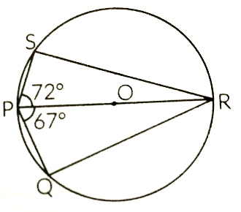  PQRS is a cyclic quadrilateral such that PR is a diameter of the circle. If ∠QPR = 67° and  ∠SPR = 72°, then ∠QRS =  a) 41° c) 67°  b) 23° d) 18° | 1
3. | If perimeter of an equilateral triangle is 6 cm, which of the following is its area  a) $\sqrt{3} cm^{2}$ b) $\frac{3}{4} cm^{2}$ c) $\frac{\sqrt{3}}{2} cm^{2}$ d) $\frac{3}{2} cm^{2}$ | 1
4. | A chord is 24 cm long and is 9 cm away from the centre of the circle. What is the radius of the circle?  a) 12 cm b) 17 cm c) 15 cm d) 16 cm | 1
5. | Which of the following is not true for a parallelogram?  a) Opposite angles are equal  b) Opposite sides are equal  c) Diagonals bisect each other  d) Sum of all angles are equal to two right angles | 1
6. | A, B, C are three distinct points on a circle with centre O. if AOB is diameter and AC = BC, then which of the following is the measure of ∠BAC?  a) 30° b) 45° c) 60° d) 90° | 1
7. | The angles of a quadrilateral are in the ratio 4: 5: 10: 11. The angles are  a) 36°, 60°, 108°, 156° c) 52°, 60°, 122°, 126°  b) 48°, 60°, 120°, 132° d) 60°, 60°, 120°, 120° | 1
8. | The point of intersection of any two diameters of a circle is called  a) Centre c) Radius  b) Chord d) Diameter | 1
9. | The length of each side of an equilateral triangle of area $9\sqrt{3} cm^{2}$ is  a) 8 cm c) 4 cm  b) 36 cm d) 6 cm | 1
10. | Assertion (A): A quadrilateral is cyclic if and only if the sum of its opposite angles is 180°  Reason (R): In a cyclic quadrilateral, the opposite angles are supplementary because they subtend the same arc in the circle.  a) Both (A) and (R) are true, and (R) is the correct explanation of (A).  b) Both (A) and (R) are true, but (R) is not the correct explanation of (A).  c) (A) is true, but (R) is false.  d) (A) is false, but (R) is true. | 1
11. | If the diagonals of a parallelogram are equal, then show that it is a rectangle | 2
12. | Find the area of a triangle, two sides of which are 18 cm and 10 cm and the perimeter is 42 cm. | 2
13. | 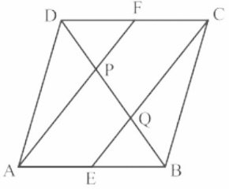  In a parallelogram ABCD, E and F are the mid-points of sides AB and CD respectively. Show that the line segments AF and EC trisect the diagonal BD. | 2
14. | 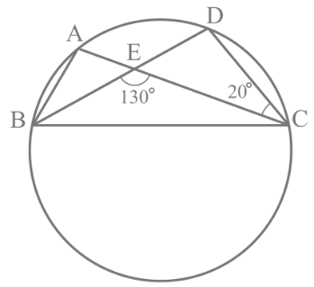  In Fig., A, B, C and D are four points on a circle. AC and BD intersect at a point E such that ∠ BEC = 130° and ∠ ECD = 20°. Find ∠ BAC. | 2
15. | 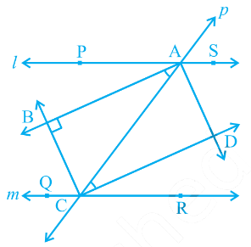  Two parallel lines l and m are intersected by a transversal p. Show that the quadrilateral formed by the bisectors of interior angles is a rectangle. | 3
16. | If the non-parallel sides of a trapezium are equal, prove that it is cyclic.  or,  Prove that a cyclic parallelogram is a rectangle. | 3
17. | The sides of a triangular plot are in the ratio of 3 : 5 : 7 and its perimeter is 300 m. Find its area. | 3
18. | Navya and Manik went on a field trip to a riverbank. They noticed a triangular piece of land that they wanted to measure and calculate its are. The made the following observations: Navya measure the lenghts of the three sides of the triangular piece of lands as 7 m, 9 m, and 11 m. Manik measured the lenghts of the three sides of the same triangular piece of land as 10 m, 12 m, and 15 m.  Based on the information answer the following questions:  i) Using Navya’s measurement, what is the area of the triangular piece of land?  ii) Using Manik’s measurement, find the semi-periemeter of the triangular piece of land and its area.  iii) Find the ratio of the area of the triangular piece of land using Navya’s measurements to Manik’s measuremts. | 3
19. | Show that the bisectors of angles of a parallelogram form a rectangle.  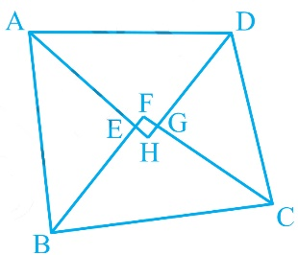  Or,  Prove that the quadrilateral formed (if possible) by the internal angle bisectors of any quadrilateral is cyclic. | 5
20. | 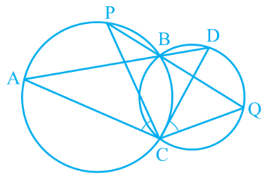  Two circles intersect at two points B and C. Thro5 m.ugh B, two line segments ABD and PBQ are drawn to intersect the circles at A, D and P, Q respectively. Prove that ∠ ACP = ∠ QCD. | 5

